CSE6224 – Software Requirement Engineering

Campus Wellness Portal with

Medical System and Fitness Center

Integration Project – Part 1

Project Vision

Tutorial Section: TT6L

Group 4

|  |  |
| --- | --- |
| Group member | Student ID |
| Nicholas Thong Meng Shui | 241UC2415Y |
| Muhammad Anas bin Khairul Azman | 241UC2401Z |
| Fikrul Amsyar Azmin | 241UC24167 |

# Group discussions:

## Microsoft Teams Group Discussion:

### **Initial Group Creation:**

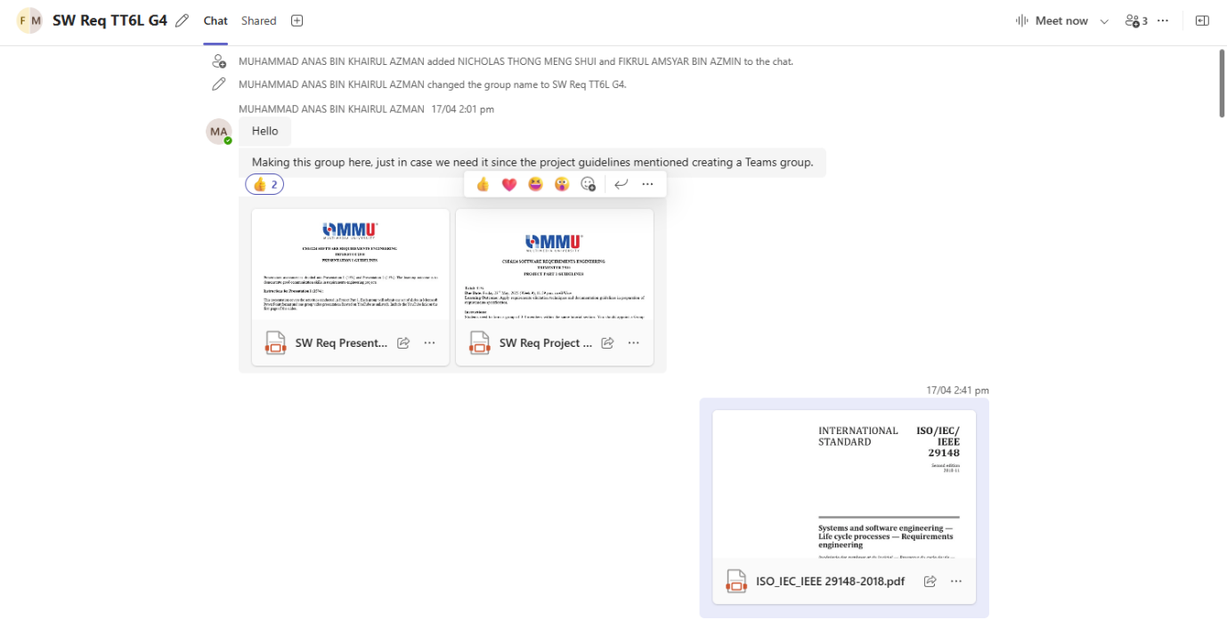

### **Project Preliminary discussions:**

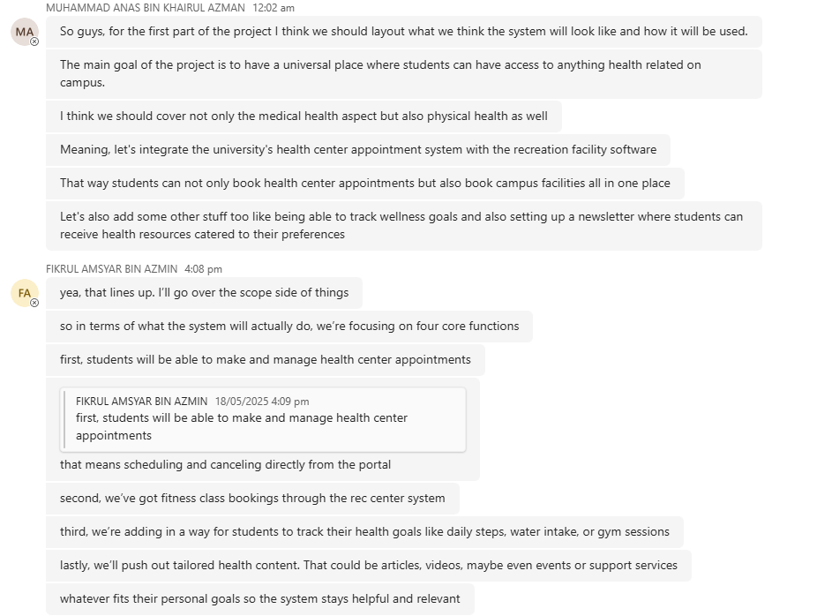

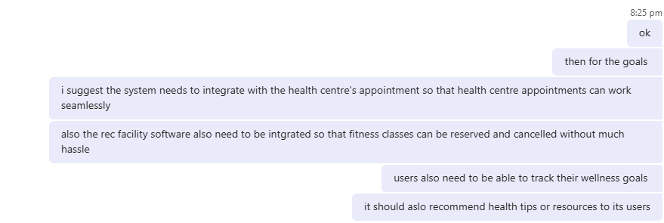

# Project Vision

This project involves developing a wellness platform that integrates with the university health center's appointment system and campus recreation facility management software. The system will enable students to manage their holistic wellness by scheduling health center appointments, booking fitness classes, tracking personal wellness goals, and receiving tailored health resources.

# Scope

The system shall:

1. Make and cancel health appointments
2. Book and cancel fitness classes
3. Tracks wellness goals
4. Receive tailored health resources

# Goals

By the end of the project, these are the goals that must be met with the wellness platform portal:

1. Successfully integrate the university health centre’s appointment system.
2. Users are able to schedule and cancel appointments from the portal.
3. Successfully integrate with the campus recreation facility software.
4. Users are able to book fitness classes and sports facilities within the portal.
5. Users are able to track their personal wellness goals.
6. Users receive health resources which are catered to their needs and personal wellness goals.